**MOTIVA Dataset - User Guide**

**Introduction**

This document provides a detailed description of the files included in the MOTIVA dataset. It serves

as a guide for researchers and users who wish to understand and utilize the dataset effectively.

**Dataset Files Description**

**Test Time.csv (CSV)**

Contains timing information for the tests. It includes columns such as 'Test ID', 'Start Time', and 'Duration'.

**Test Descriptions.pdf (PDF)**

A document describing the different tests performed, their objectives, and execution details.

**README.txt (TXT)**

General information about the dataset, including version, authorship, and usage instructions.

**Sensor_Details.pdf (PDF)**

Contains detailed specifications about the sensors used in the study, including placement, calibration, and

accuracy.

**Metadata.xml (XML)**

Metadata file structured according to the DDI standard, documenting dataset variables, events, and sensor

data.

**RAW Data (Folder)**

Directory containing raw sensor data collected during the tests. Files are stored in CSV format per sensor.

**Detailed Explanation of Key Variables**

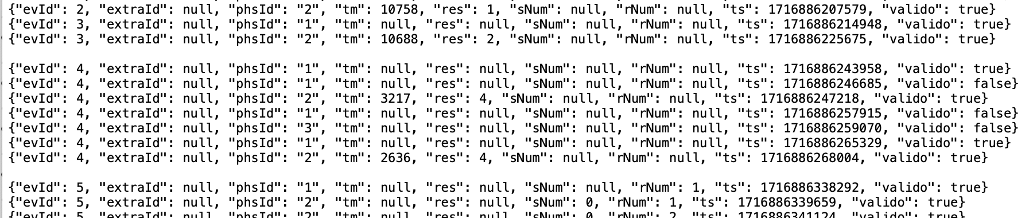

**evID - Exercise Identifier (Yellow)**

Represents the exercise being performed according to the following mapping:

1: SPPB_FEET_TOGETHER

2: SPPB_SEMITANDEM_FEET

3: SPPB_TANDEM_FEET

4: SPPB_3M_WALK

5: SPPB_CHAIR_STANDS

6: WALKING_ON_LINE

7: HEEL_TO_TOE_WALK

8: OBSTACLE_COURSE

9: WALKING_IN_FIGURE_8

10: WALKING_WITH_BALL

11: STAIRS_UP_DOWN

12: LIFTING_BOTTLE

13: SQUEEZING_BALL

14: WRINGING_TOWEL

15: LEG_EXTENSION_WITH_ANKLE_WEIGHT

16: ASSISTED_CHAIR_RISE

17: SIMULATED_SQUAT

18: UNASSISTED_CHAIR_RISE

19: LEG_STRETCHING

20: ARM_STRETCHING

21: ARM_STRETCHING_WHILE_SEATED

**phsID - Phase Identifier (Red)**

Indicates the phase of the movement:

1: Outward phase

2: Return phase (end of movement)

3: Null (undefined phase)

**sNum - Series Number (Red)**

Represents the series number in the dataset. Each test or trial may be broken into multiple series, allowing better segmentation of the recorded data.

**rNum - Repetition Number (Red)**

Indicates the repetition number of the exercise within the session. This is useful to track multiple attempts of the same test

**ts – Timestamp (Red)**

Represents the UNIX timestamp in milliseconds, indicating the exact time when the event occurred

**Valido (Purple)**Defines whether the timestamp was valid for use or had faults.

**CSV File Naming Convention**



File Name Format: IdPaciente_Fecha_PosicionSensor.csv

Each CSV file follows a structured naming convention:

- **IdPaciente**: Unique identifier for the patient.

- **Fecha**: Date of the data recording in YYYYMMDD format.

- **PosicionSensor**: Indicates the location of the sensor on the body.

**Sensor Position Mapping**

1: CINTURA

2: BRAZO DERECHO (BD)

3: BRAZO IZQUIERDO (BI)

4: ANTEBRAZO DERECHO (AD)

5: ANTEBRAZO IZQUIERDO (AI)

6: MUSLO DERECHO (MD)

7: MUSLO IZQUIERDO (MI)

8: PANTORRILLA DERECHO (PD)

9: PANTORRILLA IZQUIERDO (PI)

**CSV File Column Descriptions**



The CSV files contain the following columns, representing sensor data collected during the execution of

different exercises. Each row corresponds to a specific time instance where the sensor recorded data.

**timestamp (s)**

Time stamp in seconds from the start of data collection.

**milisegundos (ms)**

Time stamp in milliseconds for higher precision.

**acc_x**

Acceleration along the X-axis in m/s².

**acc_y**

Acceleration along the Y-axis in m/s².

**acc_z**

Acceleration along the Z-axis in m/s².

**gyro_x**

Angular velocity along the X-axis in rad/s.

**gyro_y**

Angular velocity along the Y-axis in rad/s.

**gyro_z**

Angular velocity along the Z-axis in rad/s.